**Brooklyn torah gazette**

**For parshas shemini 5782**

Volume 6, Issue 28 (Whole Number 283) 1 Nissan 5782/ April 2, 2022

**Finding the Real You**

**By Rabbi Joey Haber**



One of the more intriguing stages of the seder on Pesach is yahatz – when we split the middle matzah. We take the larger piece and put it in a bag, while the small piece stays on the table.

It is customary for the children to steal the bag with the large piece of matzah and then hide it. The bag is then brought to the table at the end of the seder, and we eat that piece of matzah.

What is the meaning of this practice? There are two parts to every person: our public persona, and our true, inner selves. The way we appear on the outside tells only part of the story. The way we conduct ourselves in public, with our friends and in the community, is the small part of our beings.

The larger portion is our inner selves, the part that people don’t see. This is the way we conduct ourselves in private, when we are alone, when we are home, with just ourselves and our families. The truth of a person is expressed in the way he responds when a random collector asks for charity, when his name is not going to be on a plaque and he is not going to be honored at a dinner.

Of course, all charity is precious, but the “larger piece” of one’s essence is the way he gives in private, when he is not seen. The truth of a person is expressed in the way he speaks with his wife in the privacy of their home, not when they walk into a wedding hall together smiling and happy. It is the behavior in the home that is the “larger piece.”

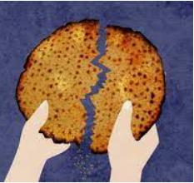

At the seder, we break the matzah and hide the larger piece. We show that the more significant part of who we are is the part that is hidden, that can’t be seen by other people. Only the smaller piece of matzah stays on the table, out in the open – to show that the public part of our beings, the part that people see, is only a small part of who we are.

The more substantial portion is the one which is hidden from public view, which nobody sees, the way we act in the privacy of our homes. We bring the larger piece to the table towards the end of the seder, because this is what the seder is about – finding our true selves, discovering who we truly are.

This is why it is the children who hide the large piece of matzah – because the children know who we really are. They are the ones who know whether we are patient or short-tempered, generous or selfish, sincere in our religious observance or not.

People outside the home see only the tip of the iceberg, but our children see the actual iceberg – our true selves. And so, they hide the large piece of matzah, because they know who we really are. The current crisis, as difficult and challenging as it is, offers us a unique opportunity to learn about ourselves. The vast majority of us are spending the vast majority of our time inside our homes, with our families. This is a chance to focus our attention on the “large piece of matzah,” and to find out who we really are. Without leaving our homes, we are able to get a good look at our true selves, to know ourselves better, to learn about our essence.

Let us use this rare opportunity to find the “real you” – and to make sure that the “larger piece” of our beings is just as good, if not better, than the “smaller piece” that shows outside the home.

*Reprinted from the Parshat Tzav 5782 edition of iTorah.com*

**Rav Avigdor Miller on**

**Weeping for Lost Tzadikim**



**QUESTION:** **At the outset of the shiur the Rav said that we shouldn’t be distraught when tzaddikim are niftar from this world.  But shouldn’t we be upset because we don’t have their guidance and also that we don’t have the protection they give us by just existing?**

**ANSWER:** It’s a good question.  Shouldn’t we have been upset when, let’s say, the Chofetz Chaim passed away? Shouldn’t we be upset that a great man passed away?

**Death of a Tzaddik is Worse than the**

**Burning Down of the Beis Hamikdosh**

Absolutely we should be sad. The Gemara says when a tzaddik chalilah dies, מלמד שקשה סילוקן של צדיקים כשריפת בית אלקינו – it’s like the Beis Hamikdosh was destroyed.  And don’t think it’s just a mashal.  The truth is that the death of a tzaddik is worse than the burning down of the Beis Hamikdosh because a tzaddik builds up in himself all the great Torah ideals, all the greatness of Torah and Awareness of Hashem; he trained himself to think about Hashem and to love Him and to walk in His ways. And therefore, this man becomes in his mind a Beis Hamikdosh.  He built a Beis Hamikdosh right here in his head! And when he dies it’s like the Beis Hamikdash was destroyed. So of course, we weep. Absolutely.  Absolutely!

Now, are we weeping because we’re missing his guidance, his wisdom? Suppose the tzaddik would have said, “I’m resigning. I’m not going to give any more advice to anybody.  I’m going into a hermitage.”  Nobody would weep that much.  We weep mostly because of commiseration; sympathy for the fact that a great man lost his  life.

Of course, the truth is that when a tzaddik goes lost, it’s a loss for us. A tremendous loss! The mere fact that he lived was a benefit for us.  Even if a tzaddik doesn’t speak a word, his presence on this earth is a benefit for us.

And so, we weep for that loss; the destruction of a Beis Hamikdash as well as the loss of a tzadik who benefited us by his mere presence. However, there’s a certain limit to our mourning.  And after that limit is passed, we are consoled because we know the tzaddik is in Gan Eden.  We cannot imagine the happiness of the reward in the afterlife.  No matter what you’ll say, you’re going to understate it.  It’s such an eternal ecstasy that the tzaddik is enjoying right now that it’s impossible to have sympathy for him now.

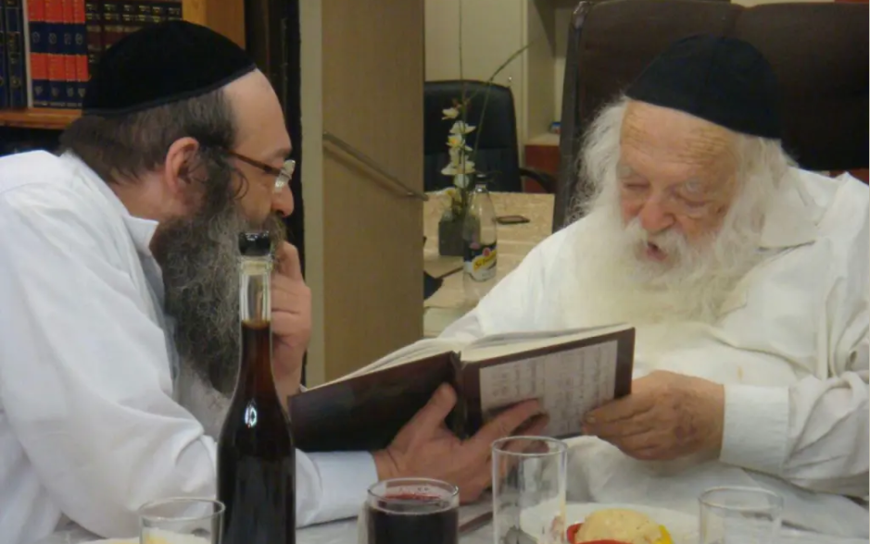

Let’s say, the Chofetz Chaim; I remember when he passed away.  I was present at the hesped in Kovno.  After all these years, am I going to weep that he passed away?  He wasn’t going to live forever after all.  He’s in the next world now. The only thing I can do is envy him.  That’s all I can do; I’m jealous of him; of his happiness, of his success forever and ever.

And so, that’s how we should view all the things in this world – as Hashem views them.  And everything in this world is nothing but a preparation for our great career in the World to Come. This tzaddik prepared his whole life for the World to Come and that is our consolation, that we know he’s in Gan Eden now.

*Reprinted from the March 20, 2022 email of Toras Avigdor. Adapted from Tape #E-43*

**Learning from the Kohen**

**the Importance of Being Compassionate to Other Jews**

**From the Talks of the Lubavitcher Rebbe**

**Rabbi Menachem Mendel Schneerson, Zt”l**

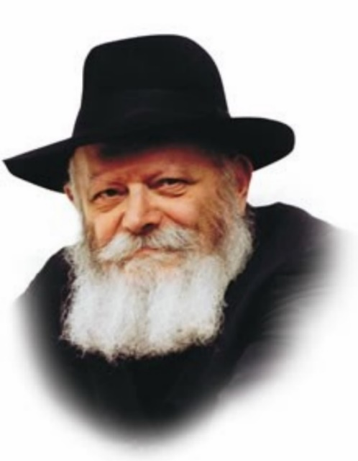

This week's Torah portion, Tazria, speaks of one of the most serious forms of ritual impurity, the disease of tzara'at. A person thus afflicted (called a "metzora") was sent outside the Jewish camp and lived in total seclusion until he was cured.

The only authority qualified to determine if an individual had tzara'at and was required to leave the camp was a kohen (priest), as it says, "When the disease of tzara'at is in a man, he shall be brought to the priest...and the priest shall see him and pronounce him impure...for all the days that he bears the affliction...he is impure...."

Even the greatest Torah authority was not permitted to establish the existence of tzara'at if he was not a priest. The only opinion that bore weight was that of the kohen, and his decision was accepted as law.

Why couldn't a Torah authority establish the existence of tzara'at? Why did this have to be done by a kohen?

The answer is revealed when we consider the punishment incurred by the metzora. A metzora was required to undergo a particularly harsh form of punishment: banishment and isolation from the rest of society. The metzora, forced to leave the camp of Israel, was seemingly cut off from the entire Jewish people.

By nature, kohanim are merciful people. Their hearts are filled with love for their fellow Jews, as reflected in the Priestly Blessing: "...Who has sanctified us with His mitzvot and commanded us to bless His people Israel with love."

The Torah recognizes that a priest will not rush to judge his fellow Jew impure. The priest is reluctant to pronounce a person a metzora, thereby subjecting him to severe punishment. The kohen will go to great lengths in order to spare another person suffering.

The Torah relies on a kohen's judgment as it knows he will make the determination of tzara'at only when there is no other choice. For this reason, the ability to establish tzara'at, and the accompanying responsibility for condemning a fellow Jew to social isolation, is given solely to him.

This contains a lesson for all of us:

We must never deem a person worthy of censure and shun his company, even if his behavior appears defective. No flaw is so great that it warrants rejection of our fellow Jew.

Instead, the first thing we must do is examine our own conduct and motivation. Are we seeing another Jew's defects out of love for him, or are we merely recognizing character defects in others because they exist within ourselves? For it is only once we are sure that we are acting out of genuine love that we may approach another person and speak to him about correcting his behavior.

*Reprinted from the Parshat Tazria 5757/1997 edition of L’Chaim. Adapted from Likutei Sichot Vol 27.*

**A Tzaddik in Our Midst: Rabbi Mendel Bernstein zt”l**

**By Rabbi Yair Hoffman**

Sometimes, we can daven for years next to someone, and be entirely unaware of lofty spiritual stature of that individual. This week (November 16, 2021), the Far Rockaway community suffered a tremendous loss with the passing of Reb Mendel Bernstein zt”l. Reb Mendel a”h was a member of the Agudah of Long Island and a well-liked talmid chochom.

He was mekabel kol odom b’saiver panim yafos. But there was much more to this remarkable individual. He grew up in Hartford, Connecticut and even at a young age had a remarkable desire for ruchniusdika growth. His religious background was more.

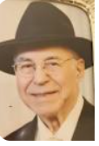

**Reb Mendel Bernstein zt”l.**

When he was in the seventh grade, Rav Aharon Kotler zt”l was visiting his adopted daughter, Gruna Katz, and Reb Mendel took the opportunity to seek his guidance about how to be mekarev his peers. Rav Aharon responded that he should work on himself and will therefore be a good role model for others to emulate. Reb Mendel became that role model – and even more.

He went on to study in yeshiva Ner Yisroel in Baltimore and became close with both with Rav Yaakov Ruderman zt”l and Rav Dovid Kronglass zt”l. Later, he studied in the Chevron Yeshiva under Rav Yechezkel Sarna zt”l. Reb Mendel had been a director of a Young Israel camp in Cleveland, Ohio and soon became engaged to his future aishes Chayil.

Rav Kronglass zt”l came to the Chasuna, which was a rarity. Rav Ruderman was mesader Kiddushin. The young couple soon accepted a position as principal of the newly formed Akiva Academy in Dallas, Texas. It was March of 1962. They arrived six months before the school was to open. He and his wife helped build Dallas into the Torah community that it is today, with Yeshivos, shuls, day schools and even a Kollel.

Reb Mendel held meetings with parents, rabbis, holocaust survivors. Slowly but surely, he built the enrollment of the school in the few months before he arrived. He had three teachers and twenty-three students. In those days, the Dallas Jewish community was under the influence of the American Jewish Council, a Reform affiliated group that was anti -Jewish rituals and anti-Israel.

In 1965, a phone call was made to Rabbi Bernstein in the third year of the school’s existence by a wealthy individual from Temple Emanuel, a Reform congregation. They would offer the Akiva Academy $10,000 if Rabbi Bernstein would just take off the Hebrew lettering on one side of the bus that picked up the kids. “It is a small cosmetic change,” the person said. Rabbi Bernstein stood his ground. He refused the donation – which at the time was a pretty hefty sum.

Reb Mendel was not only a dynamic and sincere mechanech – he was a master pedagogue who had earned his degree from Johns Hopkins University. He taught classes with much enthusiasm. He would play LP records of Jewish music to inspire and enthuse the young students. He also reached out to the parents of the Akiva Academy talmidim and talmidos. He employed a unique Torah U’Mesorah curriculum that covered very wide-ranging topics.

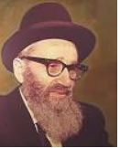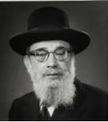

**Rav Dovid Kronglass and Rav Yaakov Ruderman**

Many of these mothers even earned certificate of completions in these courses! The parents later remarked that Rabbi Bernstein’s classes and the certificates they had earned were transformative.

The students developed very rapidly as well. They became ambassadors to the school and it grew and grew. The enrollment grew by leaps and bounds and a new building was built in the late sixties. Rabbi Bernstein also served as the Rav of the minyan in the school. Rabbi Bernstein’s family was growing and it was time to return to the East Coast.

He soon earned a living in financial markets, and served as the role model that Rav Aharon Kotler zt”l recommended that he become. Remarkably, hundreds of people that came in contact with Rabbi Mendel Bernstein zt”l became observant through their interactions with him. Reb Mendel zt”l’s legacy is twofold. He is a role model to hundreds of others as to what one individual can accomplish. He also leaves remarkable children who follow his path of inspiring others in Yiddishkeit. One son, Reb Ephraim, is the principal of Toras Emes Kamenetz in Brooklyn. Even at the Shiva house, he reached out to talmidim and others inspiring them in Yiddishkeit. His rebbitzen remarked, “He fulfilled his mission and tafkid.” May he be a meilitz yosher for all who knew him. (Rabbi Yair Hoffman for 5tjt.com)

*Reprinted from the Parshat Shmini 5782 email of whY I Matter, the parsha sheet of the Young Israel of Midwood in Brooklyn edited by R’ Yedidye Hirtenfeld..*

**Rabbi Berel Wein**

**On Parshas Tazria**

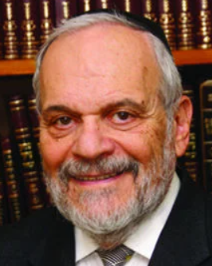

In this week's Torah reading, we are informed, almost in passing, of the commandment regarding circumcision of male children at the age of eight days. This commandment, which has existed forever in Jewish life, is the symbol of the covenant with our father Abraham between the Lord of Israel and the people of Israel and is one of the core rituals of Judaism.

The circumcision ceremony itself is called a brit – a covenant. It is the dedication of Jews to their faith and tradition that has remained, despite all the various attempts to destroy it in each century of Jewish existence. Throughout Jewish history, this ritual of circumcision, like the Jewish people itself, has always been under attack and criticism from the outside world.

The Romans and the Greeks, who worshiped the human body in its physical form and for its prowess, abhorred the idea of circumcision. They felt that it was a mutilation that defiled the body and its perfection. Jews, however, felt that circumcision sanctified the body, and represented the better nature of human beings – the spiritual and eternal side of human life.

Jews always believed that inevitably the body weakens, withers, and eventually disappears, and it is only the intangible parts of our existence – memory, spirit, and creativity, that endure and can be passed on from generation to generation. As such, circumcision was not so much a defilement of the human body, as it was and is a testimony to the enhancement and eternity of the human spirit. Every circumcision was a statement of renewal of the original covenant with our father Abraham, and is a testimony to the values of monotheism, human kindness, and hospitality that he represented and introduced into a pagan and hostile world environment.

Even today, there are many forces in the world that seek to deny the rights of the Jewish people to perform this core basic commandment. These groups always cloak themselves in the piety of self-righteousness. They claim to represent the eight-day-old infant, who apparently has no say in the matter. Mixed into this specious argument is the old Roman and Greek idea of the holiness of the human body and the necessity to protect it from mutilation, which still exists.

There are so-called democratic countries that even have legislated against circumcision, all in the name of some higher good and greater morality, that only they possess and understand.

It must be noted that in the Moslem world, also claiming the heritage from our father Abraham, circumcision is also an enshrined ritual and one of in its tenets of faith, but it is usually performed only when the child is much older than eight days. One of the decrees against Judaism instituted by the tyrannical Soviet Union government of the past century was the banning of circumcision. Yet, when the Soviet Union collapsed, an enormous number of Jews who were already adults, chose to undergo circumcision, to show their solidarity with their people and with the tradition of our fathers.

This phenomenon attests to the strength and permanence of this commandment amongst all Jews, no matter what their status of religious observance may be. It is this supreme act of loyalty and commitment that binds the Jewish people together with each other, and with our past, our present  and our eternity.

*Reprinted from this week’s website of rabbiwein.com*

**Parshas Ha Chodesh**

**It’s Not Fair!**

**By Rabbi Ben Tzion Shafier**

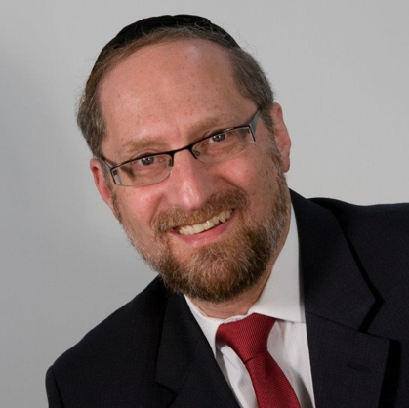

“*And you shall take a bundle of hyssops and dip it in the blood in the basin, and you shall touch it to the lintel and the two door posts, and you shall not go out, no man from the entrance of his home that night, until the morning*.” — Shemos 12:22

**Great Affront to the Mitzrim**

After months of witnessing HASHEM’s mastery over nature, the Jewish people were commanded to commit the ultimate affront to the Mitzrim: to take their very god, tie it to the bedpost, and prepare it to be slaughtered on the 14th of Nissan. They were then to take the blood of the korbon and smear it on their doorposts as a sign to protect them.

Additionally, they were told that since all first-born Mitzrim were to be killed, no Jew should leave his house that night. Rashi explains that even though blood on the doorpost was a sign that that house belonged to a Jew, if a Jew were to walk in the street, he would be in danger. “**Once permission is given to the destroyer to destroy, he doesn’t distinguish between innocent and guilty.”**

**Where is the Justice?**

It seems that Rashi is saying that had a Jew remained in his house that evening, he would not have been killed, and had he left his house, he might die – not because he was guilty of any sin, not because he deserved to die, but because once the destroyer is given permission to kill,anyone in his path is in danger

This Rashi is quite difficult to understand. If someone is innocent, then how is it possible that he would die? The basis of our entire belief system is that there is no power in this world other than HASHEM. We accept that all decisions are directly guided and carried out by Him alone. So how is it possible that someone undeserving of death would have been killed anyway, just for going outside that evening? Where is the justice?

**Immutable Laws of Nature**

The answer to this question is based on the way that Chazal understand the system of Creation. HASHEM formed this world with definite and distinct laws: heat tends to rise, gases tend to expand, and heavy objects tend to fall. These laws are the bedrock foundation for all of physicality. Just as HASHEM created laws for the physical world, so too, He created laws for the spiritual world. These are specific and exact, and carry throughout Creation.

Before HASHEM created the world, He thought (if it could be) to create it with the middas ha’din – **strict justice**. However, the world couldn’t exist if it operated according to this system, so HASHEM created the world using the middas ha’rachamim – the system of mercy. The operating principle then became compassion. The way that actions were weighed and people were judged was now with a different scale and measuring rod. However, since HASHEM acts with complete honesty, justice cannot be ignored. It is mitigated and guided by kindness, but it still demands its due.

**A Visitor in the King’s Land**

The Mesillos Yesharim explains that pure middas ha’din would demand instant punishment for a sin. After all, in this world, you are a creation, a visitor in the King’s land, created by and supported by Him. The King gave you laws for your good, and if you have the audacity to violate the express command of the King, even a slight transgression should be immediately punishable by death. The middah of mercy allows for a different way of judging an act: a sinner is given time to repent, the punishment isn’t as severe, and there is a system of tshuvah – of somehow undoing the sin itself.

However, din cannot be ignored, and there are times and situations where it comes into full force. For reasons that we humans will likely never understand, HASHEM runs this world in cycles and time settings. There are times of greater leniency, and times that demand more scrutiny in judgment. We are advised to daven on Yom Kippur with extra fervor because it is a time of greater rachamim. The same amount of regret and tshuvah on our part will accomplish more. The middah of rachamim is in greater force.

**Times of Strict Judgment**

This seems to be the answer to the question on Rashi. When HASHEM was taking retribution on the firstborns of Mitzrayim, justice was being served, and so there was a global shift in the middah in operation. Din went into effect. As such, it was a very dangerous time. Now man – any man – would be judged with the system of din, and very few individuals would be able to pass as innocent.

Therefore, the Klal Yisroel were warned, “Do not go out from your home.” The destructive angel was given permission to act in a manner different than under normal circumstances. A person who might be innocent under the normal mercy system would now be found guilty and might warrant death. Because of that, the Jews were advised to avoid the situation.

**Understanding the Middah of Din**

This concept has great applications to our lives. In many situations, we are tempted to ask questions on HASHEM. “It’s not fair! Why should that person suffer? Why do bad things happen to good people?” Yet when we focus on what man is capable of accomplishing, we understand that there are very few individuals who truly live up to their potential.

If the middah of din were exacted, there would be few who would escape unscathed. So, there are no issues of “it’s not fair.” The only question is why in one case it seems that din is in operation more than in another. And because there are so many factors that affect the balance, we humans may never know the answer to these global questions. However, the question of HASHEM’s “cruelty” never applies.

**Using the Middah of Mercy**

Even more, these concepts affect our relationship to HASHEM. When we understand what strict din is, we understand that our very existence is dependent upon mercy. We can then tap into one of the most powerful forces in Creation. Even a slight change in the amount of mercy HASHEM uses in judging me can have a fantastic difference in the outcome. The question I have to ask is: how do I awaken the middah of mercy?

One of the keys is to utilize the power of tefillah, to ask HASHEM for help – not based on my merit or anything that I have done, but out of sheer mercy. Another method is to act toward other people with mercy. Chazal tell us that the way that a person is judged mirrors the way he judges others. Since he established the criteria, that itself is justice, and in Heaven that is the scale they use.

Understanding these ideas greatly impacts the way that we approach others and the way we approach life itself.

*Reprinted from the website of TheShmuz.com*

**Recalling Rav**

**Chaim Kanievsky**

**By Rabbi Shmuel Choueka**

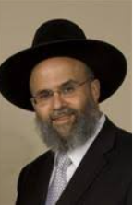 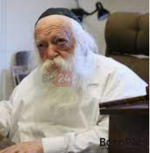

**Rabbi Shmuel Choueka Rav Chaim Kanievsky**

Last week the Jewish nation suffered a great loss with the passing of the gadol hador, Rav Chaim Kanievsky. Besides being from a family of Torah giants – he was the son of the Steipler Rav, nephew of the Hazon Ish and son-in-law of Rav Elyashiv – he was very great in his own right and was considered the premier Rav and posek of our generation.

His funeral last Sunday was attended by hundreds of thousands of people, not to mention the countless people who watched it live on video. It is therefore incumbent upon us to speak about his greatness and to use it as a springboard to commit ourselves to improve our ways.

**His Rigid and Intense Schedule of Torah Learning**

Rav Chaim had a rigid and intense learning schedule, waking up at 2:30 am every morning. Every year he would complete the entire Shas Babli, Shas Yerushalmi, Rambam, Shulhan Aruch and other important works. His learning cycle did not allow him any extra time to write his own sefarim, but since his schedule ran through the twelve months of the Jewish calendar, he had an extra thirty days in a leap year, which is when he wrote all of his sefarim.

The timing of his passing was amazing, because it was exactly twelve months after he began this year’s learning cycle! His was very dedicated to his uncle, the Hazon Ish, and to his teachings. When he was young, he studied in yeshivah in Petah Tikvah.

One day there was a berit milah in Bnei Brak that he felt he should attend, so he took a bus to Bnei Brak. When he got there, the Hazon Ish saw him and said to him, “Why are you here? You left yeshivah to come to the berit milah?”

**Immediately Took the Next Bus Back to the Yeshivah**

Rav Chaim immediately turned around and took the next bus back to Petah Tikvah. He didn’t say, “Well, I’m here already. I might as well stay for the berit milah and then go back.” If the Hazon Ish felt that he didn’t belong there, that was enough for him.

His Torah knowledge was vast and legendary. He once needed to travel to the south and was sitting in the back seat of the car with his son, when someone suddenly jumped into the front seat and said, “Oh, you’re going to the south. Mind if I join you?” They didn’t want to embarrass the man so they let him come along. Then the man turned around and said to them, “I own a dog.” (I don’t know why he felt the need to tell them this information.)

Rav Chaim then turned to his son and said, “He mentioned a dog. Let’s go through all the places in Shas that mention a dog.” And they spent the rest of the ride recalling and expounding on every place where the Gemara says anything about a dog.

**Demonstrating His Great Love for Every Jew**

Despite the fact that every minute was so precious to him, he always made time to accept visitors. Some people came to him with halachic questions, others needed advice on family or medical issues, and some simply came for his famous booha (short for berachah v’hatzlahah). Even though it took many hours from his busy schedule, he had such a great love for every Jew that he made this one of his priorities.

Rav Chaim was the Shield of our generation. His greatness in Torah protected us, and his passing is a great loss to every one of us. We need to take a lesson from his greatness and step up our Torah learning and service of Hashem. May his zechut protect us and help us to reach the final geulah, Amen.

*Reprinted from the Parshat Shemini 5782 edition of iTorah.com*